Boot your system with CentOS bootable media or ISO, you’ll get following screen.

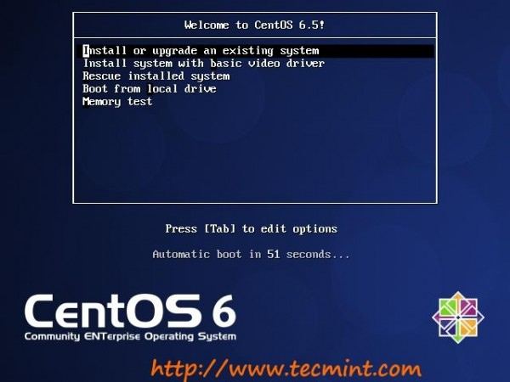
2. Check the media. You can Skip it.
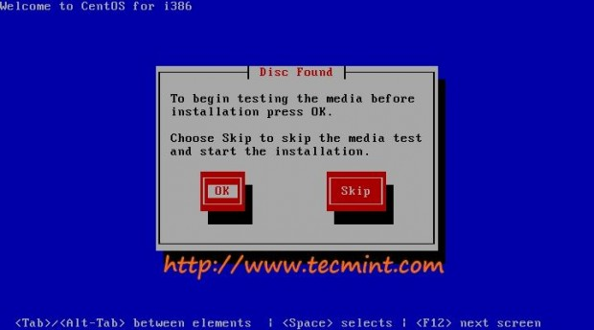
3. CentOS Installer started.
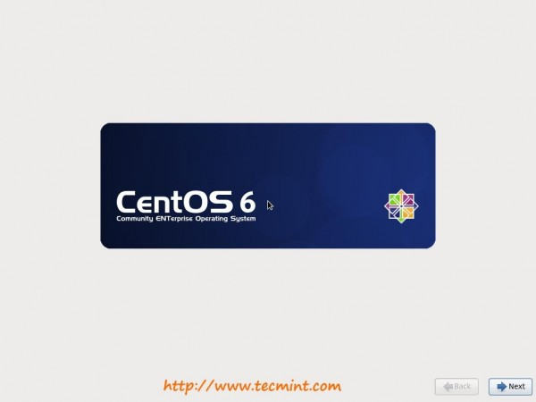
4. Language to choose during installation process.
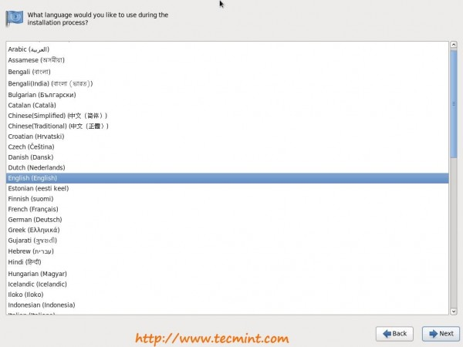
5. Select Keyboard type.
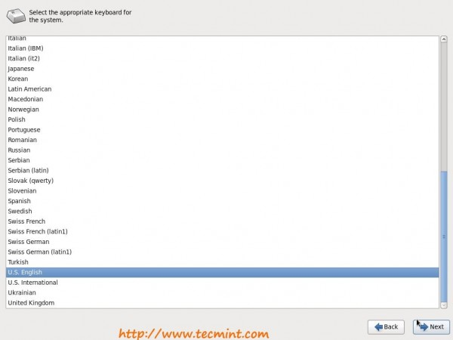
6. Select Storage Devices “Basic Storage Devices” and “Specialized Storage Devices (For advanced users)”.
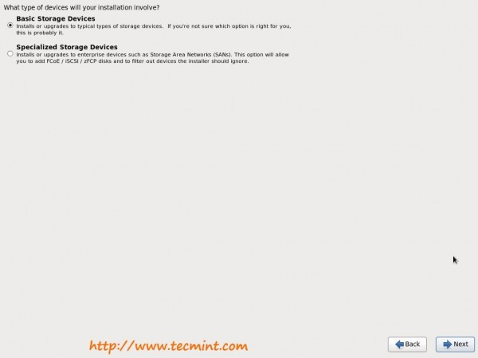
7. Storage device warning, Click “Yes, discard any data“.
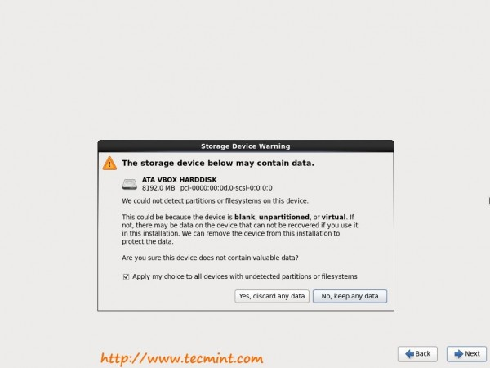
8. Give Hostname. Click on “Configure Network” button below if you want to configure network settings during installation. Same can be configure manually later on also.
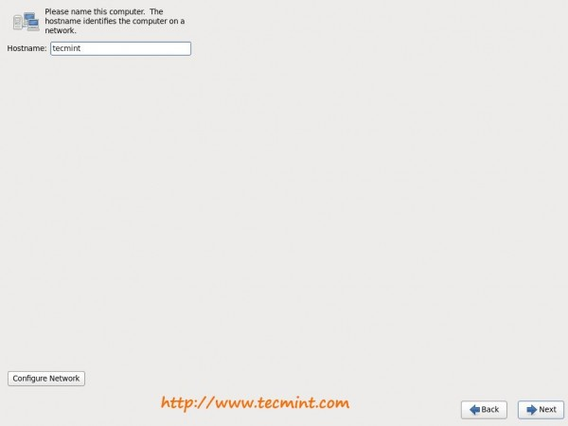
9. Select location.
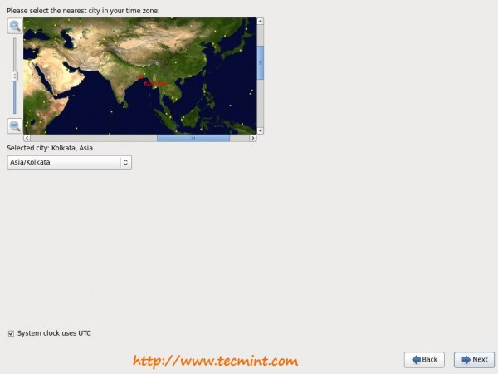
10. Set root password.
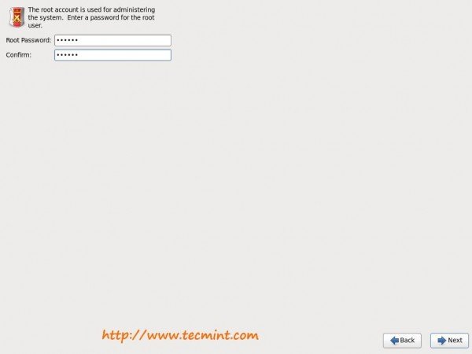

11. Select “Create custom layout “, Click on Review and Modify partitioning layout if you want to verify or edit file system manually.
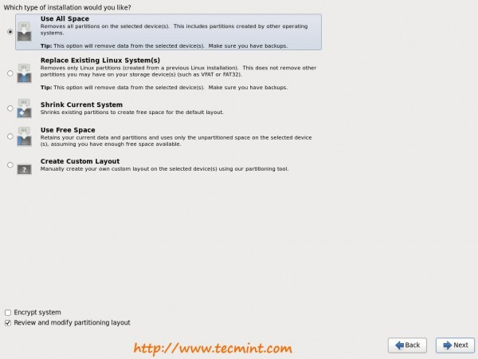
12. Partitions review.
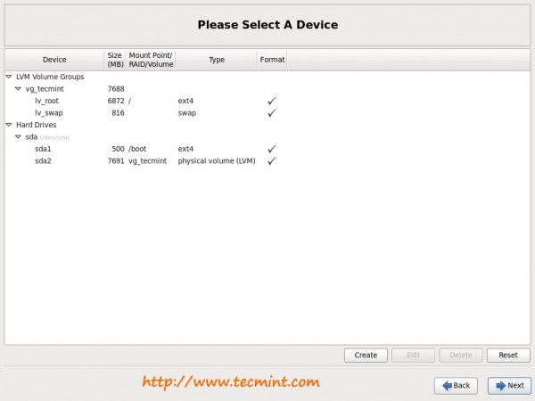
13. Format Warnings. Click “Format” which will erase existing data.
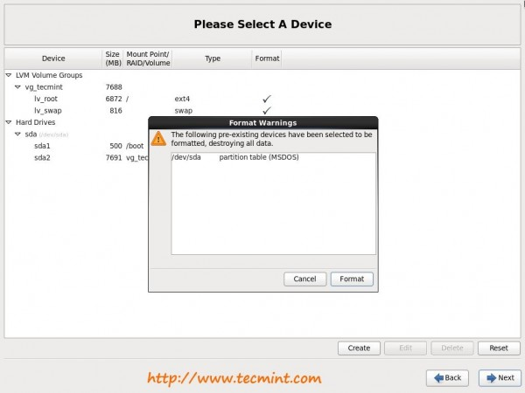
14. Writing storage configuration to disk.
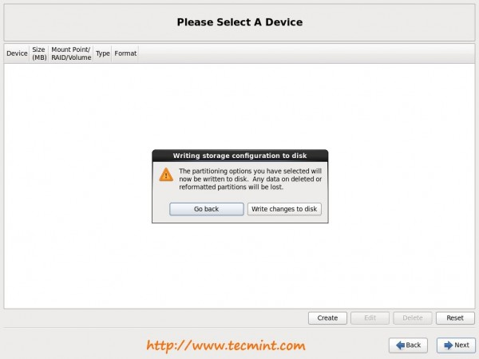
15. Formatting drive.
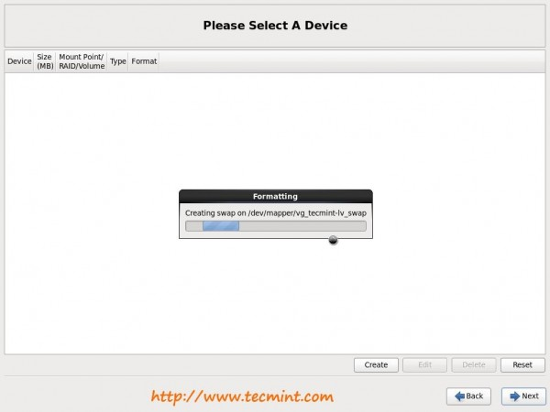
16. Bootloader installation confirmation. Check “Use a boot loader password” box if you would like to give bootloader password.
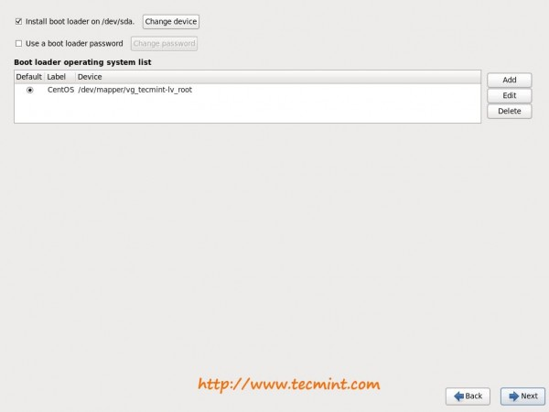
17 18. Choose application to install. Select “Customize now” further selection of software’s.
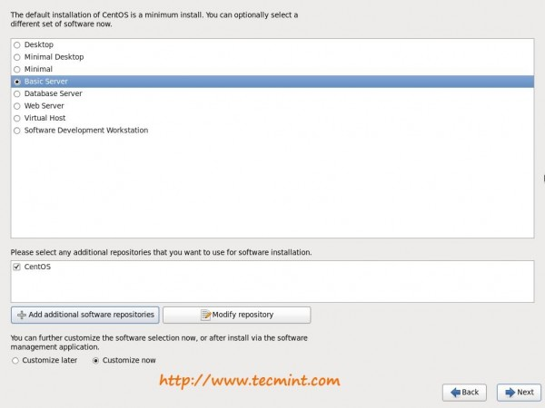
19. Select applications of your choice.
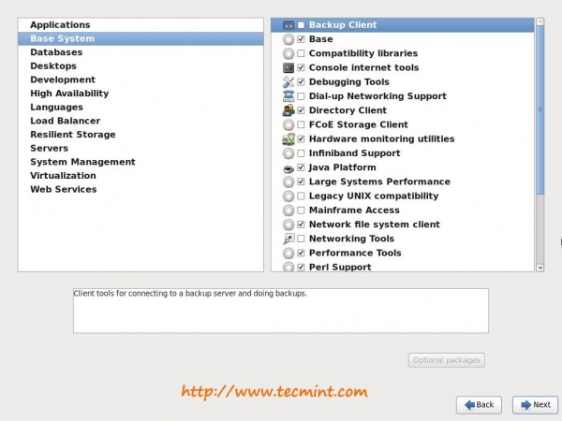
20. The installation has begun.
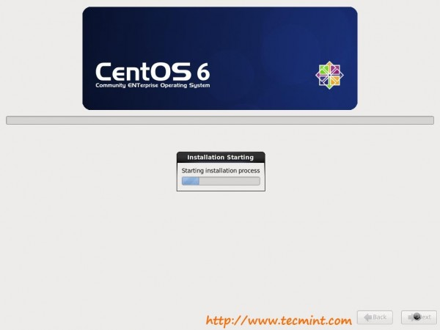
21. Relax… Installation is still in progress. Have a cup of coffee to get it 100%.
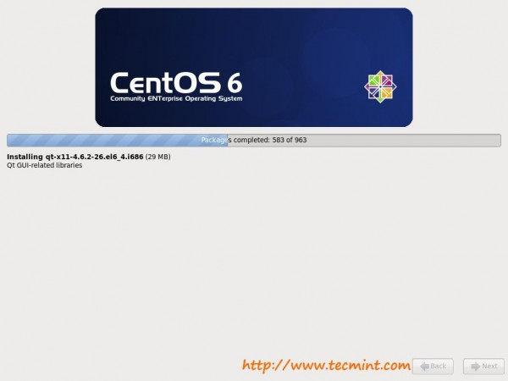

22. Installation is complete. Eject media and click on “reboot“.
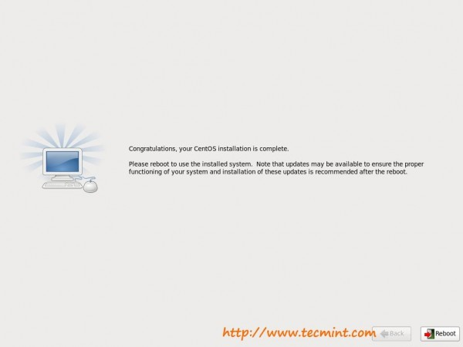
23. Login Screen.
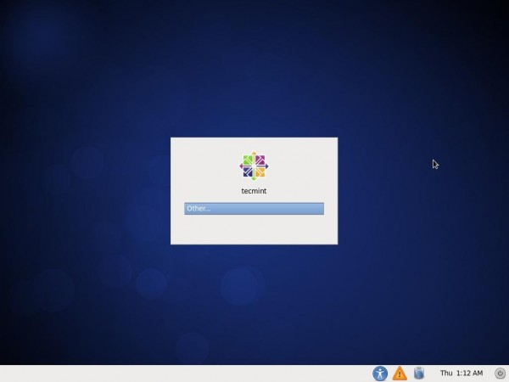
24. CentOS 6.5 Desktop.
